
Shri. Shamrao Patil (yadravkar) Educational and Charitable Trusts,
Sharad Institute of Technology, Polytechnic Yadrav
Department of Mechatronics

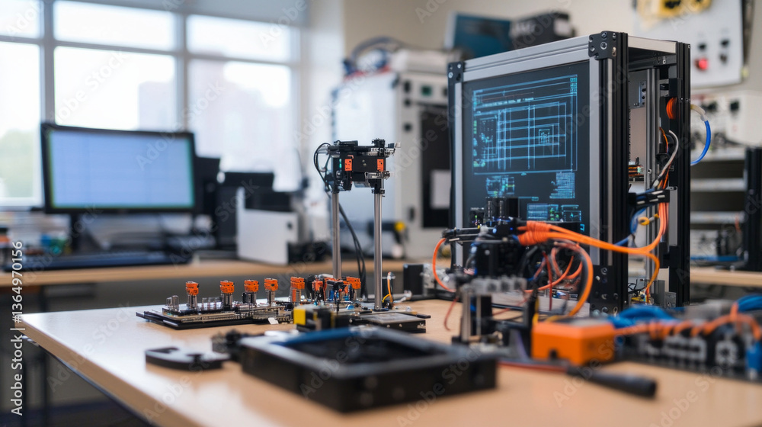
News Letter Winter 2025
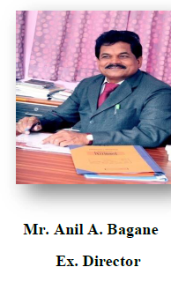
I am extremely happy to know that the department of Mechatronics Engineering is bringing out the Newsletter. Today, the role of a college is not only to pursue academic excellence but also to motivate and empower the students to be lifelong learners. So we give a harmonious personality development to our students through meditation and spiritual lectures to keep their body, mind and soul.

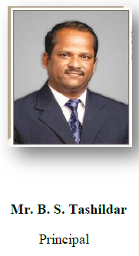
I happy to note that the department of Mechatronics Engineering is publishing its first newsletter for year 2025-26. I appreciate the efforts taken by the editorial board in compiling useful information & activities by department. This clearly reveals that the department is trying to expand in all spheres of academics, co-curricular and extra co-activities under the guidance of HOD.

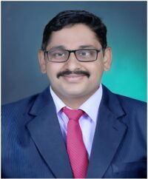
I am very happy to publish the newsletter of our Mechatronics Department. This newsletter shows the curricular, co-curricular activities carried out by the students as well as faculties during academic year 2025-2026.
Mechatronics Department is accomplished with ignited souls and creative students. I would like to thank all staff, students’ coordinator for their enthusiastic participation and great efforts.

Mr. S. S. Kothale
HOD

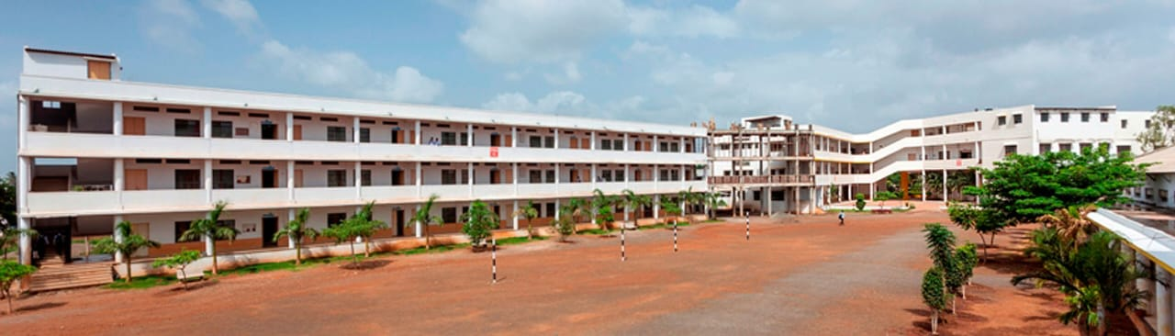

Institute Vision, Mission & Quality Policy

Vision
To be a centre of excellence in technical education by using cutting edge technology that produces competent engineers of today and tomorrow to serve the society.

Mission
M-1: To impart quality education by implementing state-of-the-art teaching- learning methods to enrich the academic competency, credibility and integrity of the students.
M-2: To facilitate a conducive ambience and infrastructure to develop professional skills and nurture innovations in students.
M-3: To inculcate sensitivity towards society, respect for environment and promote high standards of ethics.

Quality Policy

We at Sharad Institute of Technology, Polytechnic strive to achieve stakeholder satisfaction by quality education and training in science, engineering and technology in pleasant and disciplined environment through
- Involvement at all levels
- Upgradation of facilities and human resources
- Commitment to continual improvement

Vision and Mission of the Department

Vision:
- To excel in areas of mechatronics engineering by imparting quality education, relevant practices, and teaching human values to cater needs of industries and society to make successful mechatronics engineers
Mission:
- To provide strong fundamental and technical knowledge in students through effective teaching-learning methodology
- To develop professional skills in students
- Imbibe human values in students
Program Educational Objectives:
- Create a better future by pursuing higher education
- Contribute to the industry as an engineer through sound knowledge acquired in engineering
- Seek lifelong learning through moral and ethical values to meet societal needs

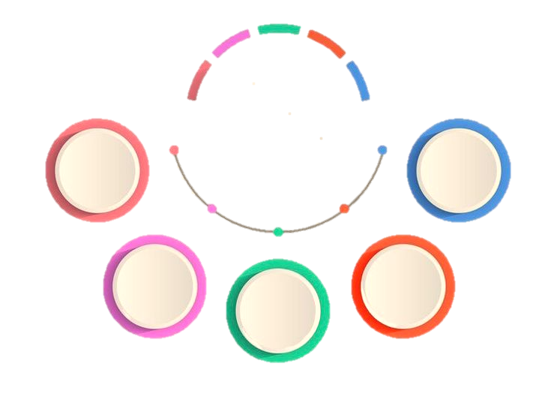
Exam Toppers

Industry Visits

MKESA
INDEX

Guest Lectures

Teaching Staff

Toppers: Second year
Rank | NAME | MARKS
1 | MUJAWAR SHAHID IQBAL | 84.89
2 | PATIL SATVIK RAJKUMAR | 77.89
2 | PATIL SOHAM SHITAL | 77.89
3 | NADAF SHAHID MIRASAB | 75.56

Toppers : Third Year
Toppers: Third yeart
Toppers: Third year

Rank | NAME | MARKS
1 | MALI AKSHAY KALLAPPA | 93.84
2 | BUCHADE PRASANNJEET ARUN | 92.07
3 | FARANDE ADITYA SUNIL | 91.7

Industrial Visit

Industrial visit is a part of a college curriculum, seen more often in an engineering course, during which students visit companies and get insight regarding the internal working environment of a company and how a company functions, as well as useful information related to the practical aspects of the educational course which cannot be visualized in lectures.
Sr. No. | Name of the company
1 | Mahabal Metals
2 | Magnewin Industries
3 | Indrani Thermo
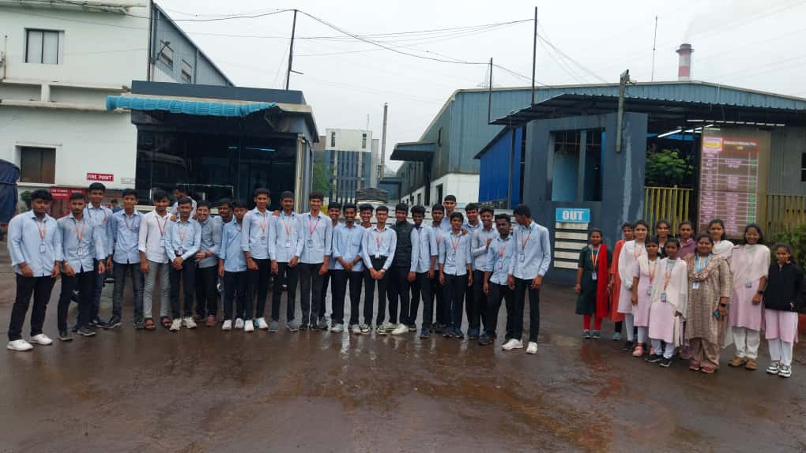

Mahabal Metals

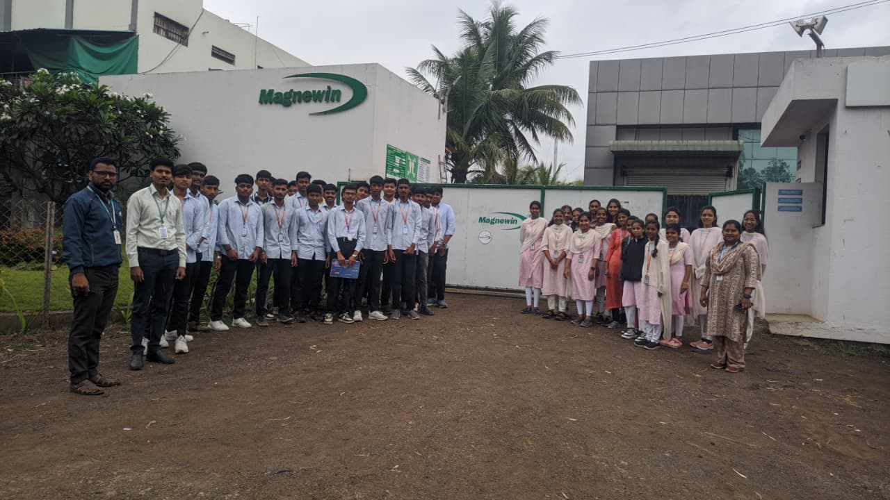
Magnewin Industries

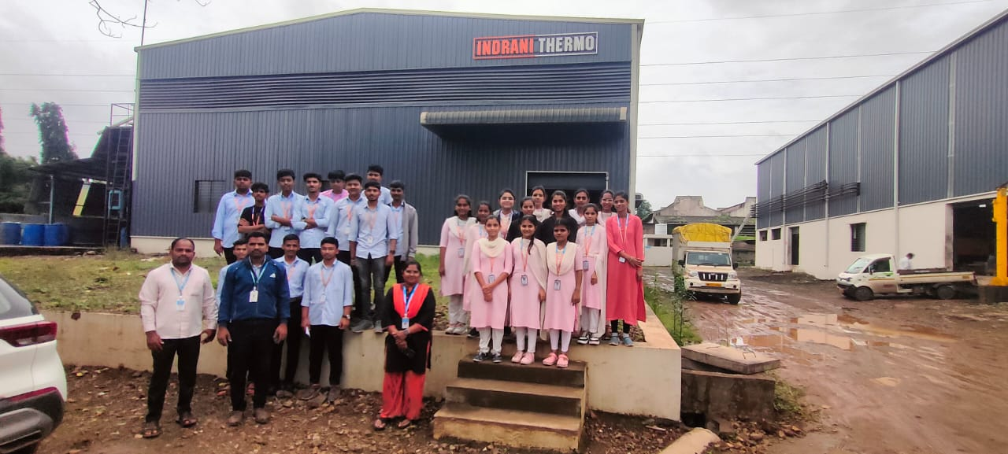
Indrani Thermo

MKESA

Aim behind this association is to carry out different activities such as paper presentation, seminars, quiz competition, group discussion, aptitude & technical test preparation etc. All the activities are arranged & carry out by the student under the guidance of faculty member.

MKESA Faculty In-Charge: Ms.P.P. BAMBARE

President: Mr. AWALE AMIT KRISHNA
Vice – President: CHAVAN HARSHWARDHAN NANDKISHOR
Secretary: TAMBEKAR SNEHA SANTOSH | Treasurer: SURYAWANSHI SHRIPAD  PRAMOD
Student Co-ordinator | SHIVRAI ATHARV GUNDU
Student Co-ordinator | KHADE VISHWAJEET KRUSHNAT
Student Co-ordinator | SANMESH RAJARAM KHOT
Student Co-ordinator | MUJAWAR SHAHID IQBAL
Student Co-ordinator | KORE PRAJAKTA BASGONDA
Student Co-ordinator | NADAF SHAHID MIRASAB
Student Co-ordinator | KOLI MANTHAN SUDHAKAR

Expert Lecture
Sr. No. | Topic | Name of expert
1 | Teamwork and Leadership Skills | Mrs. Pragati Kadolkar
2 | Elements of Indian Constitution | Mr. Karanraj Randive

Expert Lecture on “Essence of Indian Constitution “By Mr. Karanraj Randive
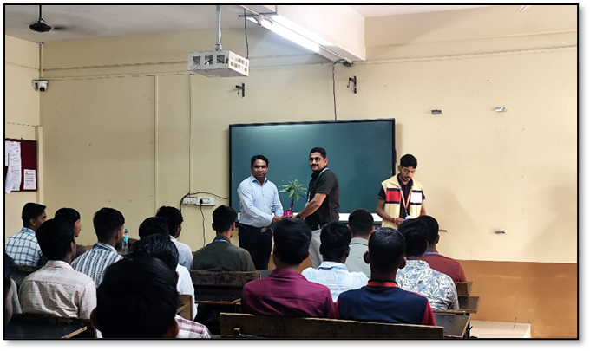

Expert Lecture on “Teamwork and Leadership Skills” By Mrs. Pragati Kadolkar

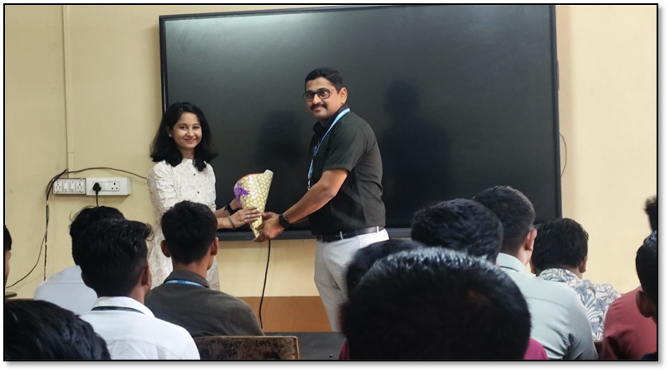

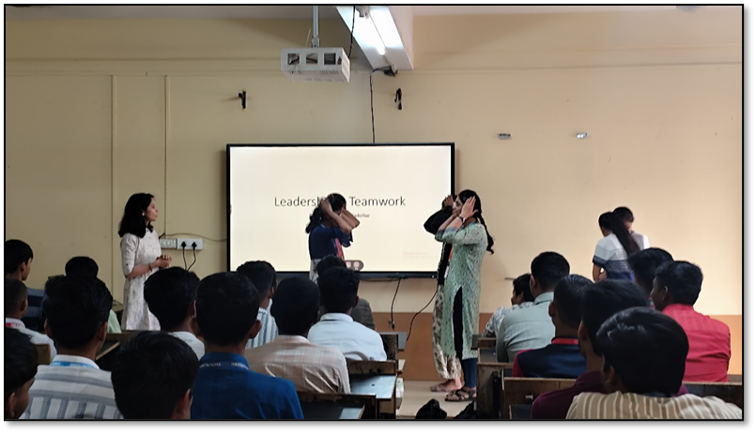

List of Teaching Staff:
Sr. No. | Name of Faculty
1 | Mr. S.S. KOTHALE
2 | Mr.S.N.BODAKE
3 | Mr.A.D. PATIL
4 | Mrs. A.N. NAIK
5 | Mr.B.B. PATIL
6 | Ms.P.P. BAMBARE
7 | Mrs. P. R. BORGAVE
8 | Mr.P.V.MOHITE
List of Non-Teaching Staff:

Sr. No. | Name
1 | Mr. P.P. GAVADE
2 | Mr. C.M. CHOUGULE

From Editors Desk

It gives me immense pleasure in presenting the issue of Mechatronics Department newsletter Winter 2025.
I consider myself very fortunate that I got opportunity to lead a very effective and co-operative MKESA team. I feel to mention here that all students of our department worked very hard throughout the year for successful arrangement of various online events during this pandemic situation.
I take this opportunity to express my deep gratitude towards respected Exe. Director Hon. Shri Anil Bagane , Principal Mr.B.S.Tashildar , Head of Department Mr. S.S. Kothale sir, my colleagues, and all students for their valuable help throughout the year.

